HCG FOUNDATION: PROPOSAL FOR MUSKAN DAAN - ORAL CANCER SCREENING

PROJECT OVERVIEW:
Project Name: | MUSKAN DAAN (Gift of a smile)
Project Title: | Oral Cancer Screening Van and Oral Cancer Screening
Submitted to:
NGO Name | HCG Foundation
Contact Person | Mr. Feros Khan
Phone number | 9986929057
Correspondence address | No. 3 Ground Floor, Tower Block, Unity Buildings Complex, Mission Road District: Bangalore, State Karnataka  PIN: 560027  Phone number with S.T.D. code: 080 – 46607760
Proposed location | Mysore – Karnataka
Proposed Budget | 5 Lakhs
Thematic Area | Healthcare

- Organizational Profile:
- Name of the organization (As per Registration) | HCG Foundation
- Registered Address | No. 3 ground floor ,Unity Building complex, mission road, Bangalore-560027
- Implementing Partner Address | 142, AB Road, near LIG Square, Phadnis Colony, Indore, Madhya Pradesh, 452008
- Website | https://www.hcgfoundation.org/
- Contact Person | Mr. Feros Khan
- Mobile number | +91-9986929057
- Email Address | feros@hcgel.com

- Legal and Registration Status:
- Date of registration | 04-12-2006
- Registration Type | Trust
- PAN | AAATH6254R
- TAN (if applicable) | BLRH03304A
- GST (if applicable) | NA
- Tax Exemption Certificate | 12A
- Tax Exemption Certificate | 80G
- Acknowledgment of Income Tax return along with IT Return filled | To be attached/To be provided upon request
- CSR Registration Number | CSR00030677
- Registration under FCRA 2010 | Date of Registration | 04-11-2023
- Registration under FCRA 2010 | Registration number | 094421886
- Darpan Registration | Date of Registration | 03-07-2018
- Darpan Registration | Registration number | KA/2017/0162762

- Details about Trustees of the organization:

Name | Designation | Appointment date
DR.B.S.AJAIKUMAR | Managing Trustee | 04.12.2006
ANJALI AJAIKUMAR ROSSI | Trustee | 22.02.2021
DR.GANESH NAYAK | Trustee | 04.12.2006
DR.RAMESH S BILIMAGGA | Trustee | 22.02.2021
SATHISH SHENOY | Trustee | 04.12.2006

- Previous Partners/Donor agencies of the organization:

- Merck Pharmaceuticals
- ABB
- Child Help Foundation
- Child Vikas foundation
- CVC Capital Partners
- Prestige Group
- Sarojini Damodaran
- NES
- Go colors

- Organizational Background: (Organization profile, vision & mission, work profile, locations the organization works at and key areas of impact and area of operation of the organization):

HCG Foundation is a unique not-for-profit organization that raises funds through donations, grants, and CSR funds to help economically marginalized patients, raise awareness about cancer and its prevention, and conduct early cancer detection camps. HCG Foundation was constituted and registered as a Public Charitable Trust on 4th December 2006 with the single-minded aim of improving the quality of life of patients by empowering them to avail the best cancer care that medical science can offer. It has helped over 6,500 patients, conducted more than 482 awareness camps since its inception catering to 85,000 beneficiaries and 2,500 students impacted by School Programs and 600 Girls Vaccinated Against HPV.

Vision: -
Ensuring access to quality cancer treatment for those in need and creating awareness on Cancer and its Prevention

Mission: -
- Provide financial support to those who cannot afford cancer treatment.
- Spread awareness of cancer and cure.
- Make early detection services more accessible for rural communities.
- Educate on healthy lifestyle habits and prevention of cancer.
- Provide psychological support to the family of cancer affected.
- Sponsor, promote and conduct research activities towards prevention, treatment and eradication of cancer.

- Awards and Recognition (if any)
- Awarded to HCG Foundation: Bengaluru NGO’s Leadership Award 2017
- Certificate of Merit Awarded to HCG Foundation: National CSR Leadership Certificate of merit 2016.

Section 2: Project Proposal
1.Proposal Abstract:
Oral Cancer Screening Van will serve the purpose of disseminating educational awareness on Oral Cancer and Cancer diagnoses and screening in the rural areas of Maharastra and Gujarat. In so doing the furthest mile will be reached on the screening of oral cancer using the oral cancer screening device. The goal of the project is to leverage pre-existing infrastructure in the local communities to continue to educate and diagnose and detect oral cancer at the early stage in rural communities.

Specific Objectives of the Project:

- Oral Cancer Screening
- Create oral cancer awareness.
- Tobacco replacement therapy for deaddiction to prevent oral cancers.
- Help people recognize the early signs and symptoms of cancer, thus enabling them to seek treatment at an early stage.
- Educate people about the key risk factors, since more than 30% of cancer cases could be prevented by modifying lifestyle or avoiding the risk factors.
- Inform people about the importance of regular screening and check-ups.

Our Expertise

HCG Foundation brings strong on-ground expertise in designing and implementing large-scale community health interventions, with a proven track record in oral cancer awareness, screening, and early detection. Our expertise is demonstrated through the successful execution of an Oral Cancer Awareness and Screening Program across rural and semi-urban regions of Nagpur district, Maharashtra. Implemented through a mobile screening model, the project combined community outreach, risk assessment, oral examinations using diagnostic tools, tobacco de-addiction counselling, and structured referral mechanisms, ensuring last-mile healthcare access for underserved populations.

Since October 2024 , the Foundation conducted over 180 screening camps, reaching more than 20,000 individuals, identifying hundreds of suspected cases, and facilitating timely referrals to government and tertiary care hospitals. The program also integrated tobacco cessation support, including nicotine replacement therapy, and focused on inclusive outreach covering women, children, and transgender communities. This hands-on implementation experience, combined with strong coordination with medical professionals, local authorities, and community leaders, positions HCG Foundation as a capable and reliable partner for executing impactful, scalable, and outcome-oriented health initiatives.

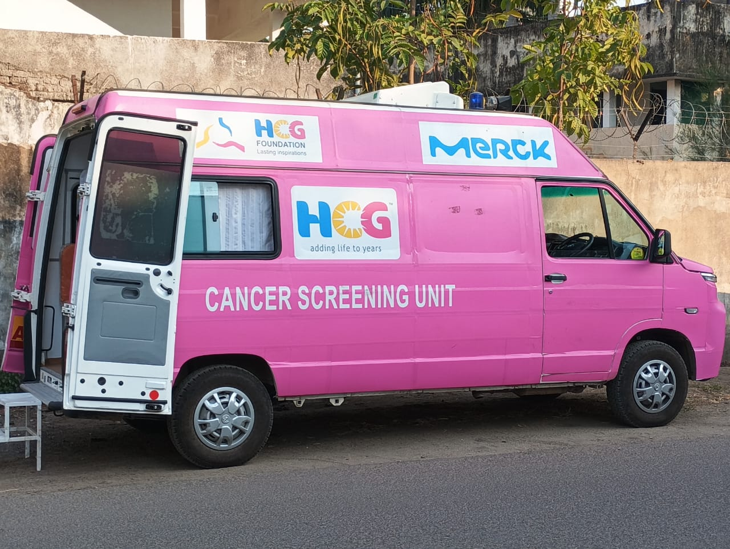

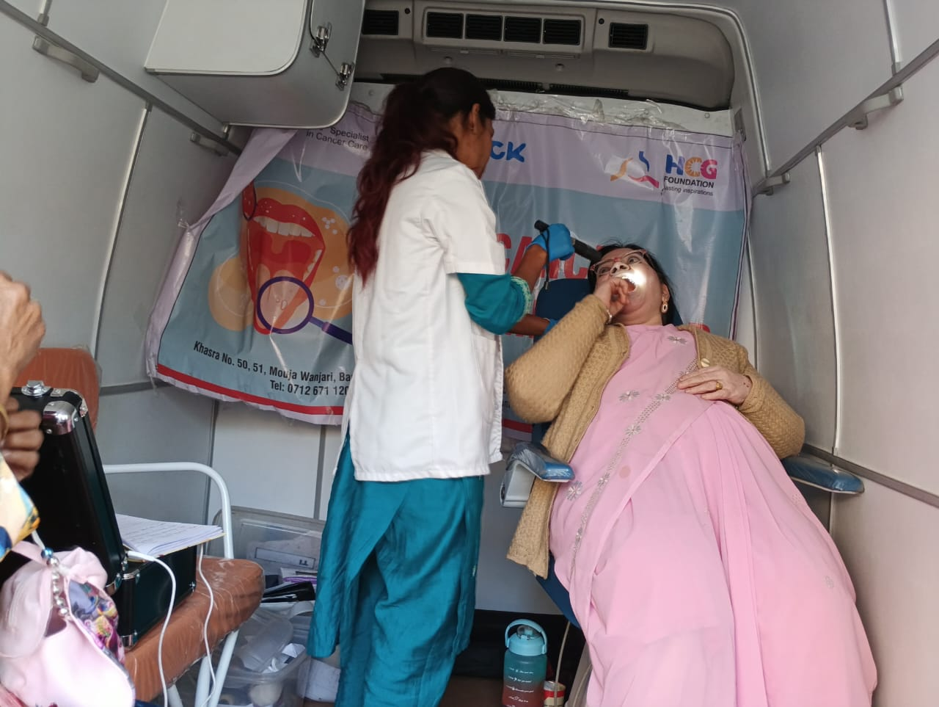

2. Background /Rationale of the Project:
Oral cancer is a largely preventable disease. Whilst numerous risk factors have been identified, two major risk factors are present in 90% of cases: smoking, chewing tobacco, and alcohol.
Early detection of the disease leads to successful treatment if the diagnosis is accurate, and symptoms are first noticed. Understanding community needs, focusing on education and awareness, and finding innovative solutions in healthcare delivery is the way of the future in India. Modifying or avoiding risk factors and implementing of evidence-based prevention strategies can reduce up to half of cancer deaths.

Tobacco: the greatest risk factor for oral cancer and is directly attributable to two in three cases. This includes smokeless tobacco such as gutka, supari, and betel quid. Tobacco consumption is responsible for almost one in 5 cancer deaths and ironically is the single largest preventable cause of cancer deaths. In India, tobacco in various forms is responsible for 30% to 60% of total cancers among males and 10% to 30% among females. Awareness and early prevention tactics can help curb this alarming statistic.

Description of the Programmes/ Activities:

As soon as the Project gets approved, the procurement of screening van, oral cancer screening device and oral cancer screening digital app will be done within 30 days. Then the discussions will be held with the Community Leaders and Taluk Medical officer regarding the objectives & implementation and schedule of the project

Awareness will start first with the local community.

- Concurrently, training will be imparted to representatives at the taluk level.
- Booklets on symptoms of oral cancer will be distributed to all participants.
- Awareness lectures will be provided by experts from HCG Hospitals.

The data collected will be tabulated and those who have symptoms of cancer will be referred to a nearest cancer center for further investigations and treatment. The information collected will be used as a comprehensive health database, for establishing Health problems in rural areas & health activities in the future can be planned accordingly.

4. Output and Outcome
In the first stage 100 cancer camps covering approximately10,000 rural people will be screened and educated on the symptoms of oral cancer, prevention techniques, and where to go for treatment. Tobacco replacement therapy for tobacco deaddiction to prevent oral cancers/malignant lesions will be provided for those who are addicted to smoking and chewing tobacco. Patients who have symptoms of cancer will be identified and referred to a nearest cancer centre. Needy patients will also be treated with the support of the HCG Foundation.
The village and surrounding areas will become well-versed in avoiding cancer-causing habits, recognizing potential harmful symptoms, and made aware of treatment options for cancer afflicted patients, undergo regular self-screening activities (where possible). Increase in number of unintended beneficiaries.
5.Sustainability of the Project
The project is designed to be sustainable and easily scalable across multiple geographies. The availability of a dedicated screening vehicle and oral cancer diagnostic equipment enables the Foundation to conduct regular camps in new and underserved areas, thereby increasing outreach and reaching a larger beneficiary base. Once the initial infrastructure is established, the project can be implemented continuously for several years with minimal incremental costs, ensuring long-term impact through early detection, prevention, and timely referral of oral cancer cases.

6.Monitoring and Evaluation Plan
There will be a rigorous process for appraising and monitoring this project. In the field, an internal project assistant will assess the timeline, resources used and needed and will thoroughly evaluate the direction of the project
On a deeper level, managers at the HCG Foundation’s Head Office in Bangalore will be continuously evaluating and monitoring the project through information digitally received from the field. On-site visits will be made if required.
Photos will be sent from the field documenting the camp from start to finish and disseminated amongst internal staff

BUDGET DETAILS-
Stage 1:
Number of Camps: 100
Number of Beneficiaries: 10,000

INFRASTRUCTURE NEEDED
A minivan – 1 Nos, Oral Cance Screening device – 1 Nos, Digital App – 1 Nos
Project Matierial Cost (2025 quotes)
Particulars |  | Unit | Cost |  | Total
Vehicle ( Screening Van) |  | 1 | 1,910,390 |  | 1,910,390
Oral Cancer screening device |  | 1 | 552,736 |  | 552,736
Oral Cancer screening digital App |  | 1 | 200,000 |  | 200,000
Project Material Total Cost 26,63,126
STAFF NEEDED
Medical Officer – 1, Nurse – 1, Admin – 1, Driver -1

Project Camp Cost
Particulars | Unit
Transdermal patches /medicines | 14000 |  |  | 100 camps |  | 2,10,000
Human resources - 4 staff – 4,00,000 | 1000 / person |  |  | 100 camps |  | 4,00,000
Petrol, 150,000 | 1000km/month |  |  | 12 months |  | 150,000
Food for the staff 100,000 | 1000/day |  |  | 100 camps |  | 100,000
Hall/printing / Misc 100,000 |  |  |  | 100 camps |  | 100,000
Admin expenses |  |  |  |  |  | 86,874
Project Camp Cost 9,60,000

TOTAL Budget: ₹36,23,123

